28.57: a)
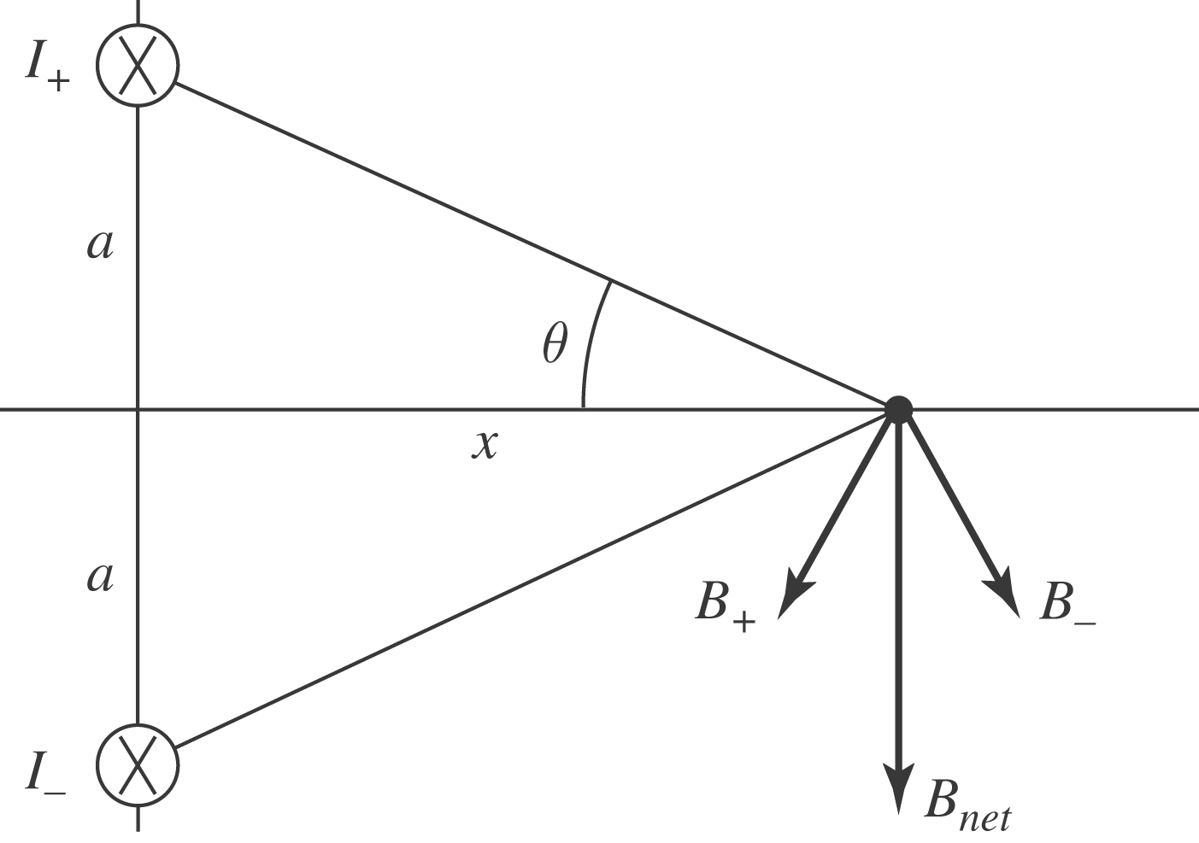

b) At a position on the x-axis:

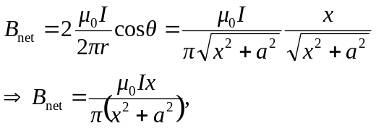
in the negative y-direction, as shown at left.

c)
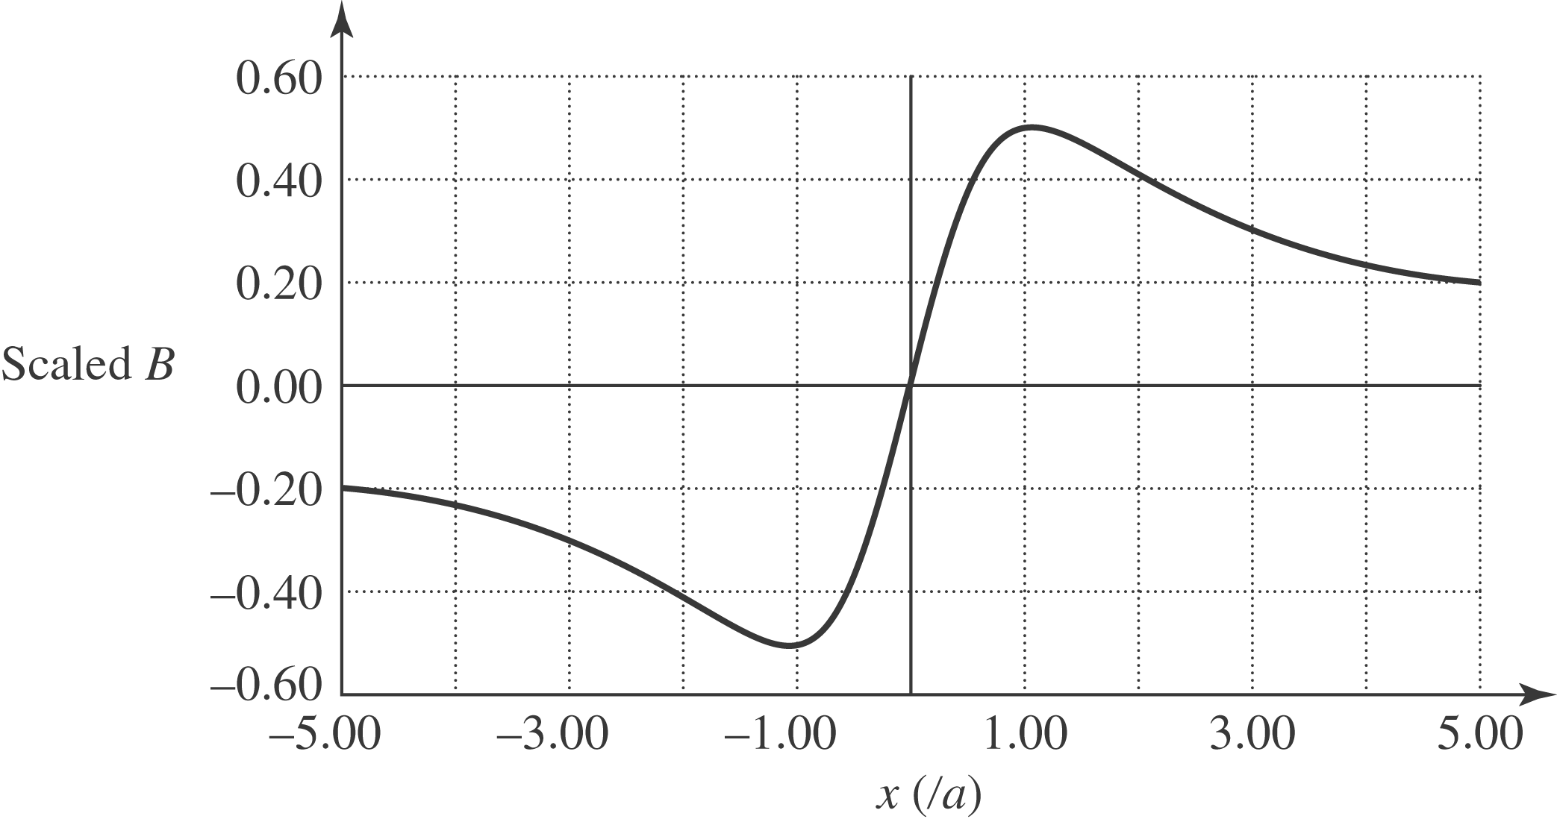

d) The magnetic field is a maximum when:
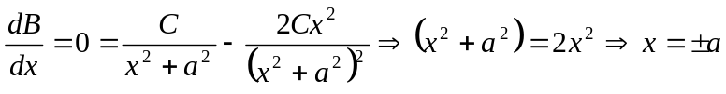
e) When 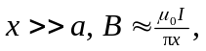 which is just like a wire carrying current 2I.

